<Insert agency logo> 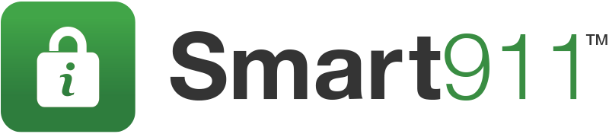

MEDIA ALERT

<Enter Location> <Enter Date>

<Enter Location> Urges Individuals to Prepare for <enter storm>
by Signing Up for Smart911

Public Safety Service Helps Emergency Responders Help Individuals During Storms,
Disasters and Emergencies

WHO: <Enter Client Name / Location>

WHAT: With <insert storm details> approaching, all residents of <Enter Location> are urged to sign up for the public safety service, Smart911. Smart911 allows individuals to create a free, secure Safety Profile online that contains important information about their household. 9-1-1 call takers can quickly leverage this data to expedite their arrival time, increase the awareness of first responders before arriving to the scene, and ultimately save lives.

WHY: Smart911 allows individuals to create a Safety Profile for their household that includes any information they want 9-1-1 and response teams to have in the event of an emergency. When a citizen makes an emergency call, their Safety Profile is automatically displayed to the 9-1-1 call-taker, allowing them to send the right response teams to the right location with the right information.

In the event of a weather emergency, responders can be aware details that can be necessary in their response including: all residents in a household, medical needs, mobility limitations, structure details including color of the home, access points to the home, and pets.

WHEN/WHERE: Individuals can sign up for Smart911 immediately and for free at https://www.smart911.com or download the Smart911 App on the Apple Store or Google Play.

If you would like further information about Smart911, please contact <insert contact> of the
<agency, email, phone>

