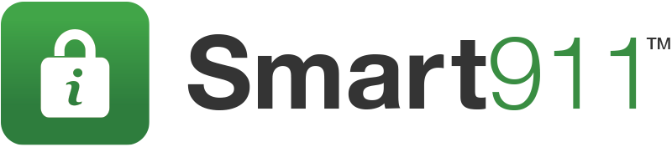
Text for Community Outreach before a Weather Emergency
Add these messages to emergency alerts or bulletins issued about storm preparation
SMS text:
SMART911.com is a free service that allows you to provide information about your household to 911 before the storm. From: <enter email contact>
SMS Text 2:
Download the Smart911 App is a free service that allows you to provide information about your household to 911 before the storm. Available on the Apple Store or Google Play. From: <enter email contact>
Email Paragraph 1:
With a severe storm approaching, <enter response agency> encourages all individuals to prepare for the weather by signing up at www.smart911.com or downloading the Smart911 App. They can provide information about their household to emergency officials. In the event you need to dial 9-1-1, we will be better prepared to help you.
Email Paragraph 2:
<enter storm details> is in the midst of development in the <enter location> area. We urge all citizens to prepare for the hazardous conditions by creating a free Safety Profile at www.smart911.com or download the Smart911 App. Through Smart911, you can provide emergency responders with the information they need to help you when you need it most. Sign up for the free service now at www.smart911.com or download the Smart911 App.

Email Paragraph 3:
Please contact <enter name> with any questions: <enter contact information>

