Exciting New Safety Feature in Rave Guardian!
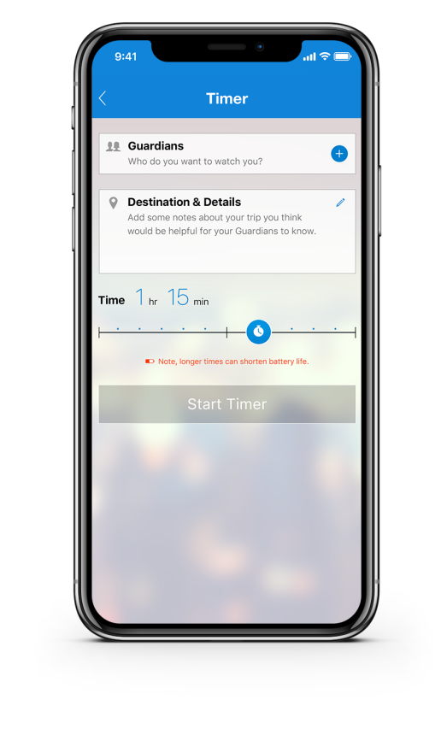
Rave Guardian app users can now ask friends and family to watch over them without the use of an app or notification of security. If Rave Guardian app users are walking late at night or traveling to new areas, they may not feel safe, but they are not alone.
In 5 easy steps, users can set a virtual safety timer to have contacts watch over them for an added layer of security.
1. Add Guardian
2. Say where they are going
3. Set duration
4. Start the timer
5. Selected contacts will get a text and can select to monitor the timer session without the use of an app.
If things escalate, an emergency call is just one click away.

STAY CONNECTED
Download Rave Guardian mobile app to stay safe.

