LET YOUR FRIENDS WATCH YOUR BACK

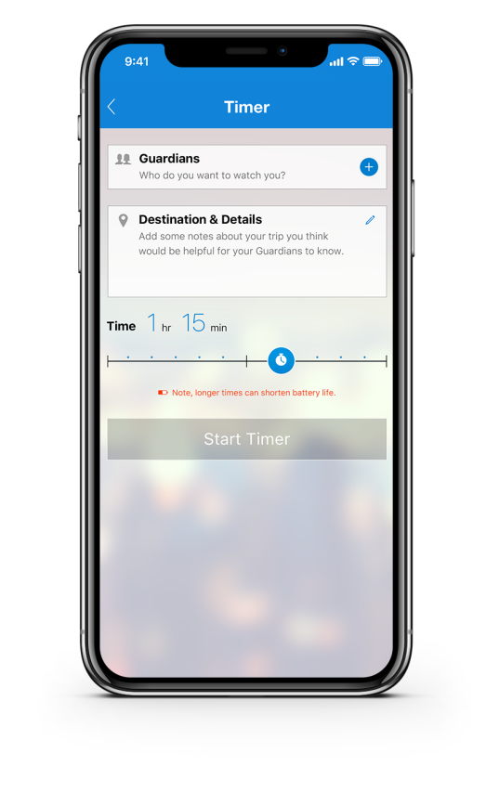
Walking late at night or traveling to new areas poses increased risks and you may not always feel safe. With Rave Guardian, you are not alone.
In 5 easy steps, you can set a virtual safety timer to have your friends and family watch over you for an added layer of security.
1. Add Guardian
2. Say where you are going
3. Set duration
4. Start the timer
5. Your selected contacts will get a text and can select to monitor the timer session without the use of an app
If things escalate, an emergency call is just one click away.

STAY CONNECTED
Download Rave Guardian mobile app to stay safe.

