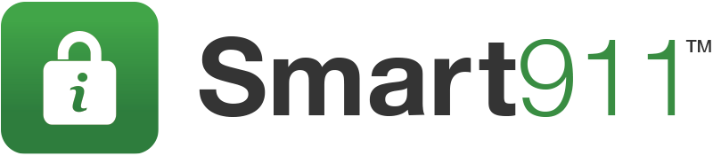
Social Media Severe Weather Content
Include this text along with provided graphics in social media communications to your community before a storm.

Facebook posts:
- ALERT: <enter storm details> in the midst of development in the area today. Travel will continue to be hazardous until <enter time>. Sign up at www.smart911.com or download the Smart911 App to provide important information to 9-1-1 officials and first responders. It could save your life!
- SMART911.com is a free service that allows you to provide information about your household to 911 before the storm. Sign up at www.smart911.com or download the Smart911 App.
- Prepare for dangerous driving conditions by signing up to give 9-1-1 call takers and first responders important information at www.smart911.com download the Smart911 App. It could save your life!
- ALERT: Dangerous travel conditions are expected today. Sign up at www.smart911.com or download the Smart911 App to provide important information to 9-1-1 officials and first responders. It could save your life in an emergency!
- ALERT: the latest regional forecast predicts hazardous driving conditions during the afternoon commute. Be smart about safety and sign up for Smart911 at www.Smart911.com or download the Smart911 App.
Twitter posts:
- Dangerous driving conditions expected. Give #9-1-1 officials the info they need to help you at smart911.com or download the @Smart911 App.
- Prepare for hazardous roads & freezing temperatures, sign up for @Smart911 to create a Safety Profile today.
- Snowfall & strong winds to continue until mid-afternoon. Are you prepared? Sign up at www.smart911.com or download the Smart911 App today.

- The wintry mix continues. Give #emergency managers the information they need to help you at www.smart911.com or download the Smart911 App.

- Prepare for hazardous weather, sign up & create your @Smart911 Safety Profile at www.smart911.com or download the Smart911 App today.

- Strong winds & hazardous road conditions predicted. Are you prepared? Sign up at www.smart911.com or download the Smart911 App today.

