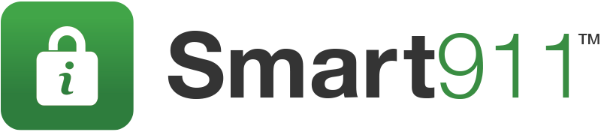

Social Media Severe Weather Content
Include this text along with provided graphics in social media communications to your community before a storm.

Facebook posts:
- How did you weather the <insert event>? Did you know there is a free service available in <insert location> to keep you safe during the next <insert event>? Sign up now and be prepared at smart911.com
- Smart911.com is a free service that allows you to provide information about your household to 911 before a <insert event>
- Be prepared before the next <insert event> by signing up to giving 9-1-1 call takers and first responders important information at smart911.com. It could save your life!
- Before the next <insert event>, be sure 9-1-1 and responders have the information they need to help you and your family. Sign up for free at smart911.com and be prepared.
Twitter posts:
- Were you prepared for this <insert event>? Be prepared for the next one, sign up at smart911.com to keep your family safe.
- Before the next <insert event>, be sure 9-1-1 and responders have the info they need to help you. Sign up at smart911.com
- Smart911.com can help you prepare for the next <insert event>. Take the time, stay safe.

