<Insert agency logo> 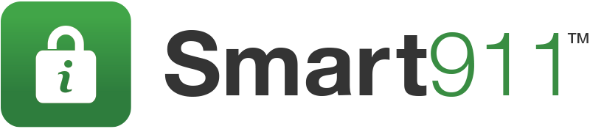

MEDIA ALERT

<Enter Location> <Enter Date>

<Enter Location> Reports on Response During <enter storm>

Public Safety Officials Urge Citizens to Prepare for the Next Storm

WHO: <Enter Client Name / Location>

WHAT: While the recovery efforts of <insert storm details> continue, officials in <Enter Location> are reminding residents to plan ahead before the next storm, by signing up for the public safety service, Smart911. Smart911 allows citizens to create a free, secure Safety Profile online that contains important information about their household. 9-1-1 call takers can quickly leverage this data to expedite their arrival time, increase the awareness of first responders before arriving to the scene, and ultimately save lives.

WHY: Smart911 allows citizens to create a Safety Profile for their household that includes any information they want 9-1-1 and response teams to have in the event of an emergency. When a citizen makes an emergency call, their Safety Profile is automatically displayed to the 9-1-1 call-taker, allowing them to send the right response teams to the right location with the right information.

In the event of a weather emergency, responders can be aware details that can be necessary in their response including: all residents in a household, medical needs, mobility limitations, structure details including color of the home, access points to the home, and pets.

WHEN/WHERE: Citizens can sign up for Smart911 immediately and for free at https://www.smart911.com

If you would like further information about Smart911, please contact <insert contact> of the
<agency, email, phone>

